/generate-otp : signing up with mobile number

/register-ap-go : continue with Apple or Google

/validate-otp

/get-merchant-screen for both buttons. /get-merchant-details also for shopkeeper.

S

This is a screen only for ShopKeepers. The questions and options will come from API so it’s a simple case of collecting data about their type of business and figuring out how many cashier tills they have. QR Code will be generated by us and we will send an encrypted version in a Print to them. They can apply that on cashier till so that consumers can scan.

/get-merchant-details

/save-merchant-details

Location is more of a formality for Shoppers. We just want their location OR post code.   
  
For Shopkeepers, we need a proper address. We plan to ringfence their premises to control AR Object at some stage.

/get-location-by-coords

/get-location-by-post

This will be slightly different for Shopper and Shopkeeper. Business, we need a logo, proper address, subscription schemes, type of business (Pub/Retail/Coffee Shop), number of cashier tills and some more relevant information.  
  
For Shoppers, simply location and their interests is good enough.

/save-profile

Shopkeeper Home Page. Local Adverts here should come from Suppliers. Until Suppliers come on-board, we can run our own adverts and provide each shopkeeper with their own offers.

Loyalty Scheme Options

Create: create-loyalty api to get data on screen, save-loyalty with createFlag = true to save the data

View: view-loyalty api with viewFlag = true to get data

Modify : view-loyalty with viewFlag = false to get all loyalty data. User will select scheme they want to change and then press save or unsubscribe, and then you send the save-loyalty api with createFlag = false

Shoppers Home Page. All offers from local shops + offers from where this Shopper has been, should come up here. Activate AR would open camera and overlap the surroundings with any offers on the shops around that user. Other screens for these icons are already done below.

/offers-near-me

SHOPKEEPER only

/create-loyalty-scheme

/save-loyalty-scheme with createFlag = true

Loyalty Scheme Cashback – SUBSCRIBE is for predefined scheme.

Loyalty Scheme Stamps – SUBSCRIBE is for predefined scheme.

Loyalty Scheme Stamps – SAVE is for custom scheme.

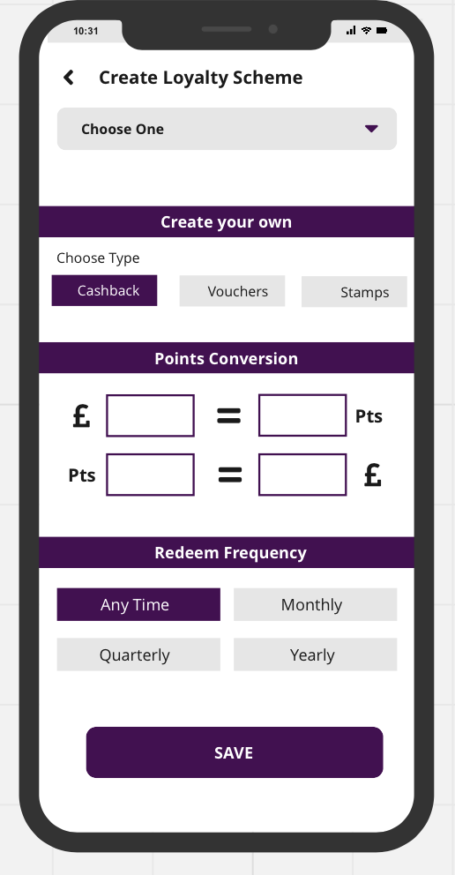

Loyalty Scheme Cashback – SAVE is for custom scheme.

s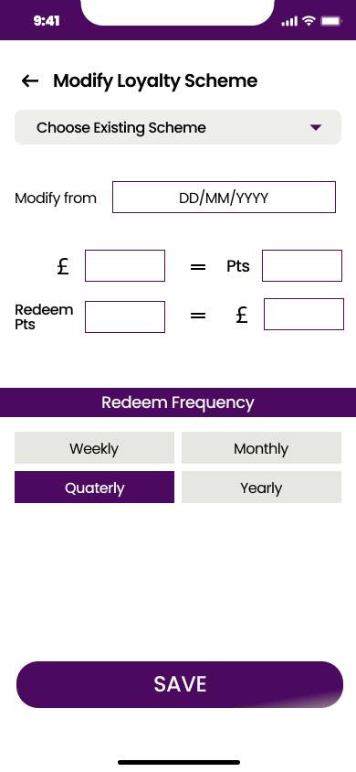

Loyalty Scheme Voucher – SAVE is for custom scheme.

Modify Custom Scheme

View-loyalty-scheme to get the loyalty data that is shown depending on scheme selected

Save-loyalty to save with createFlag = false

Modify Predefined – can only unsubscribe to a predefined scheme, not edit.

Modify Custom Cashback

Modify Predefined Stamps

Modify Custom Stamps

/view-loyalty-scheme with viewFlag as true. Gets all the user information. Details button takes to website, not implemented yet.

Shopkeepers View. Offers can be AR based or normal ones (based on subscription levels). It will send notifications to users. In the long run, we might add more user characteristics here to make sure that shopkeeper can select which users to be notified.

/create-offer

/save-offer

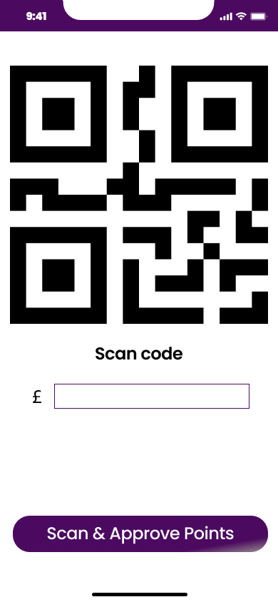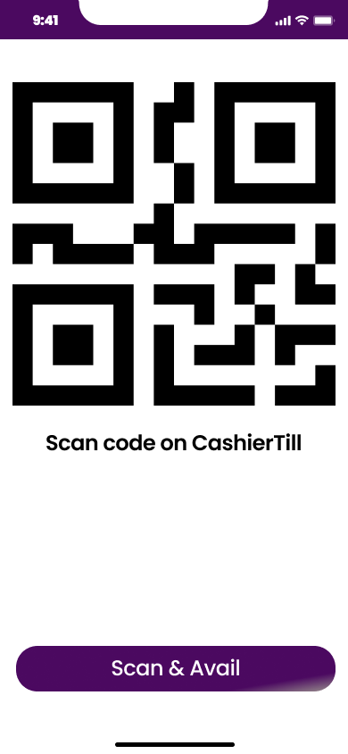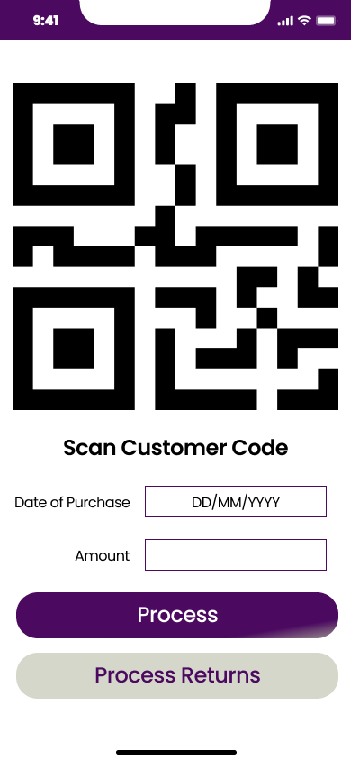

Shoppers View when location is ON and they want to see what sort of offers/shops near them. Not a Home Page as such but a link from Home Page will bring them here.

/shop-near-you

Shoppers view of the shop. They can come via click on previous page where list of shops appear. OR they can just scan the QR code and they get Shop Object along with list of current offers.

/get-shop-information

REPLACE VIEW BUTTON WITH ADD BUTTON

NEED TO ADD WALLET API.

/add-wallet

/view-wallet for ‘My Offers’

Need to add Offers Applied API as well : details for offers that user has applied showing how much money they’re saving

/offers-applied

Shoppers View. Collect Points is an icon on Home Page. They click on that, it generate a QR Code, Show it to Cashier and Cashier will scan it.

/collect-points

This is Shopkeeper’s view. He will scan the QR Code from Customer Screen, Enter Amount and click on Scan and approve. This Screen has another view on scanning. If there are any offers Availed/Added by Customer, they will appear on screen if they are valid. Shopkeeper has right to keep/remove offers based on what he sees in the shopping cart.

/approve-points

This is Shoppers view which is again activated from Home Page. It will enable users to check and avail ALL offers in one go. Just Scan and it will provide a list of all offers available. Customers can then pick and choose the offers they wish to avail.

/scan-avail

This is the nest screen from Scan and Avail. A Shoppers view to show all offers available on the shop. Keeping and Close. It will create a list of offers added and saved in the customer mobile app. While doing payments, it should generate a QR Code that will pass on ALL this information and Customer ID to Shopkeeper’s phone. The Shopkeeper can look at the list and decide to approve all, reject all, or approve some and reject some.

/get-offers-available

Put in a distance radius with options : 1-10 miles

\*\*\* AT SOME POINT \*\*\*

If you go to a shop and scan it, then those shops’ offers are more likely to appear at the top. Notifications only for those shops visited, which can obviously be stopped.

This is Shopkeeper’s view. It comes up when he scans customer screen.

Remove Free Loreum Ipsum for now.

In Addition to Points Collected, have Total Bill.

Allow a scan and save of a receipt : you want record of transaction for returns.

Points Collected ->

£y spent

x points redeemed

Redeemable points

This is Shopkeepers view of Returns. He has to scan Customer ID (QR) and then add date of purchase, amount (Returned only) and then process returns. This is to make sure that points earned on this item are taken out from Customer Points.

NO QR CODE, MUST SCAN RECEIPT.

Shopkeeper scans returned receipt, and from that can get date of purchase and amount and returns are processed.

can get userID and therefore any points associated with the transaction as well.